**Event Report: National Mathematics Day**

**Name of the Event:** National Mathematics Day  
**Date:** 22nd December 2024  
**Venue:** Government Degree College, Gummalakshmipuram  
**Organized by:** Department of Mathematics  
**Guest of Honour:** Dr. T. Sreevaram, Principal

The Department of Mathematics organized National Mathematics Day on 22nd December 2024 to commemorate the birth anniversary of the legendary mathematician **Srinivasa Ramanujan**. The event was conducted with the aim of inspiring students to appreciate the importance of mathematics in various fields and to honr the contributions of Ramanujan to the world of mathematics.

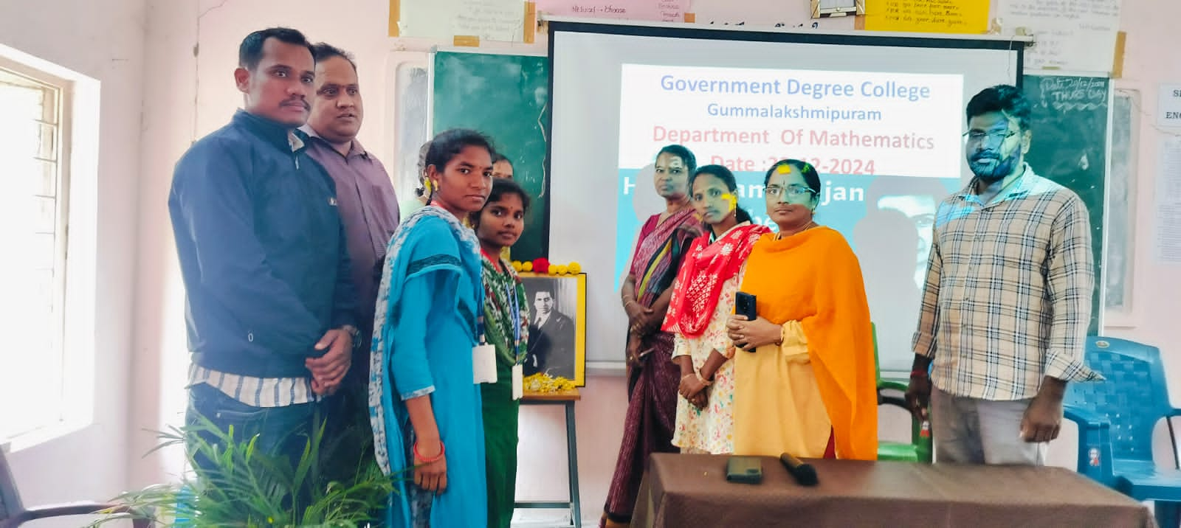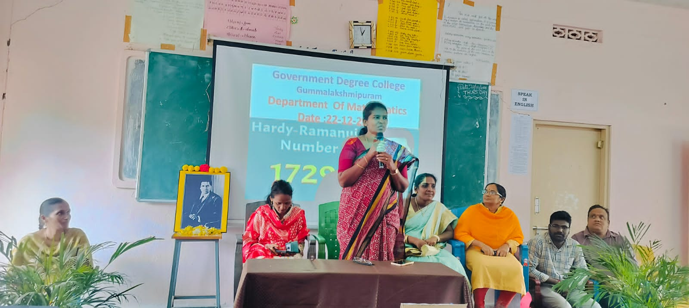

The event commenced with a welcome address, followed by an inspiring speech by the Chief Guest, **Dr. T. Sreevaram**, Principal of the college. In her address, she emphasized that with dedication and passion for mathematics, students can achieve great success and reach new heights in their academic and professional careers.

**Smt. Tulasi**, Lecturer in Mathematics, delivered an insightful talk highlighting the life, achievements, and extraordinary contributions of Srinivasa Ramanujan to mathematical theories and research. She explained how Ramanujan’s work continues to influence modern mathematics and research globally.

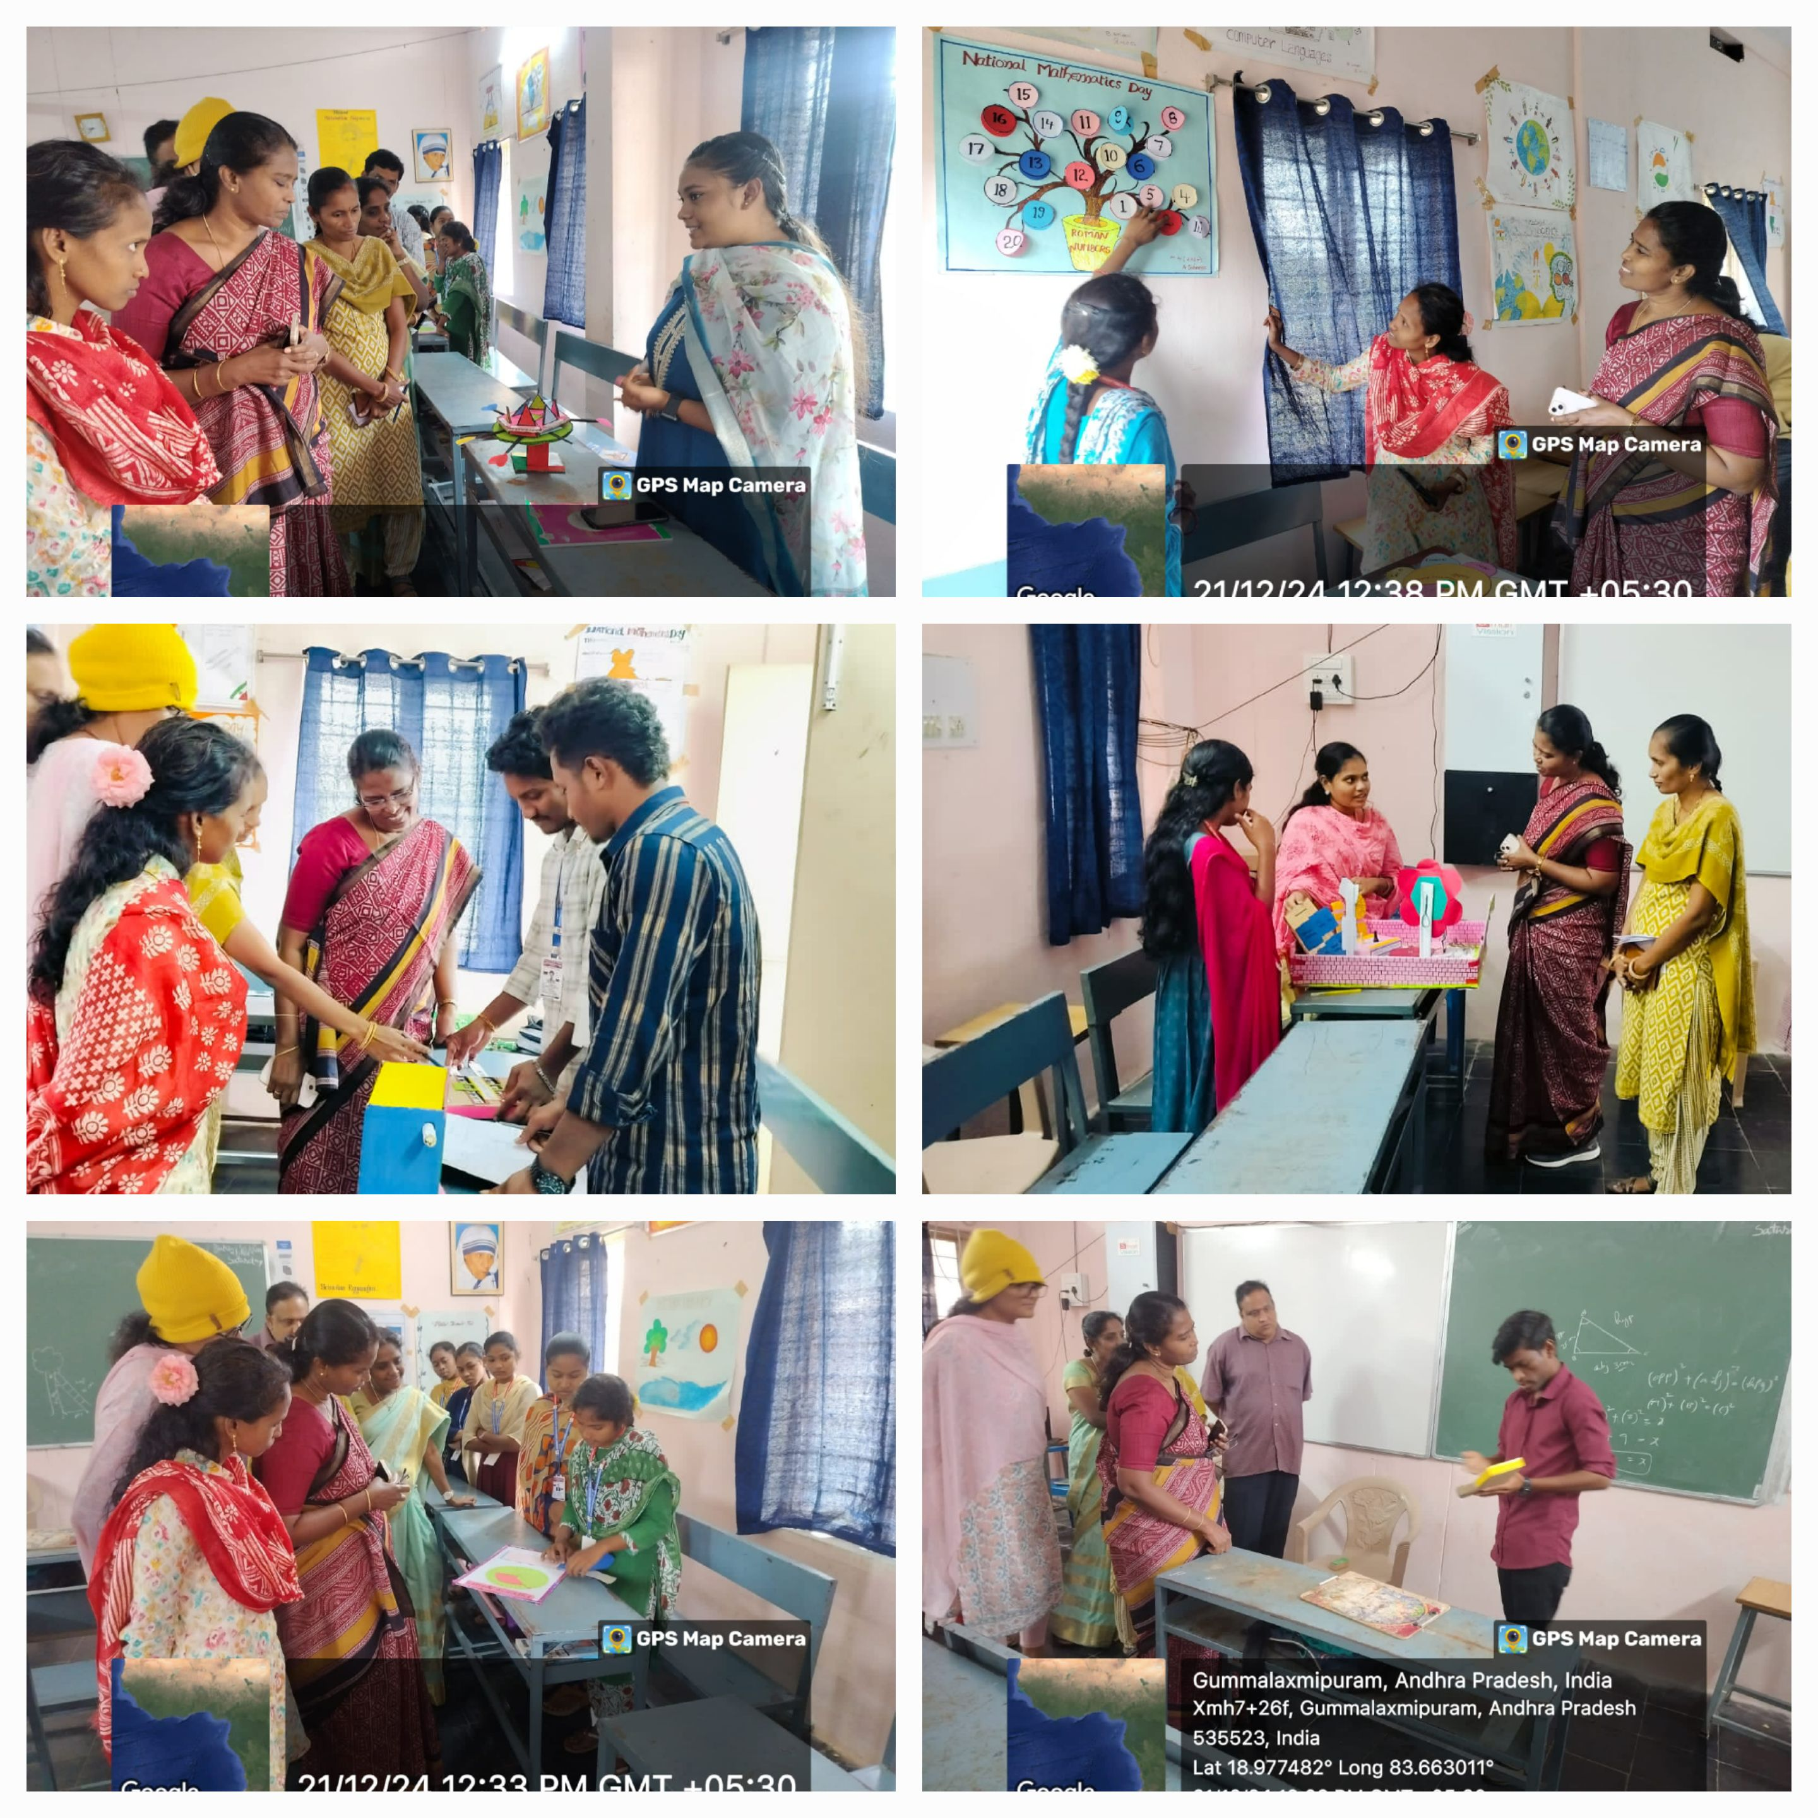

As part of the celebrations, students actively participated by presenting **mathematics projects**, showcasing their understanding and creativity. A panel evaluated the projects, and the **best project was awarded a prize** to encourage and recognize the students' efforts and innovation.

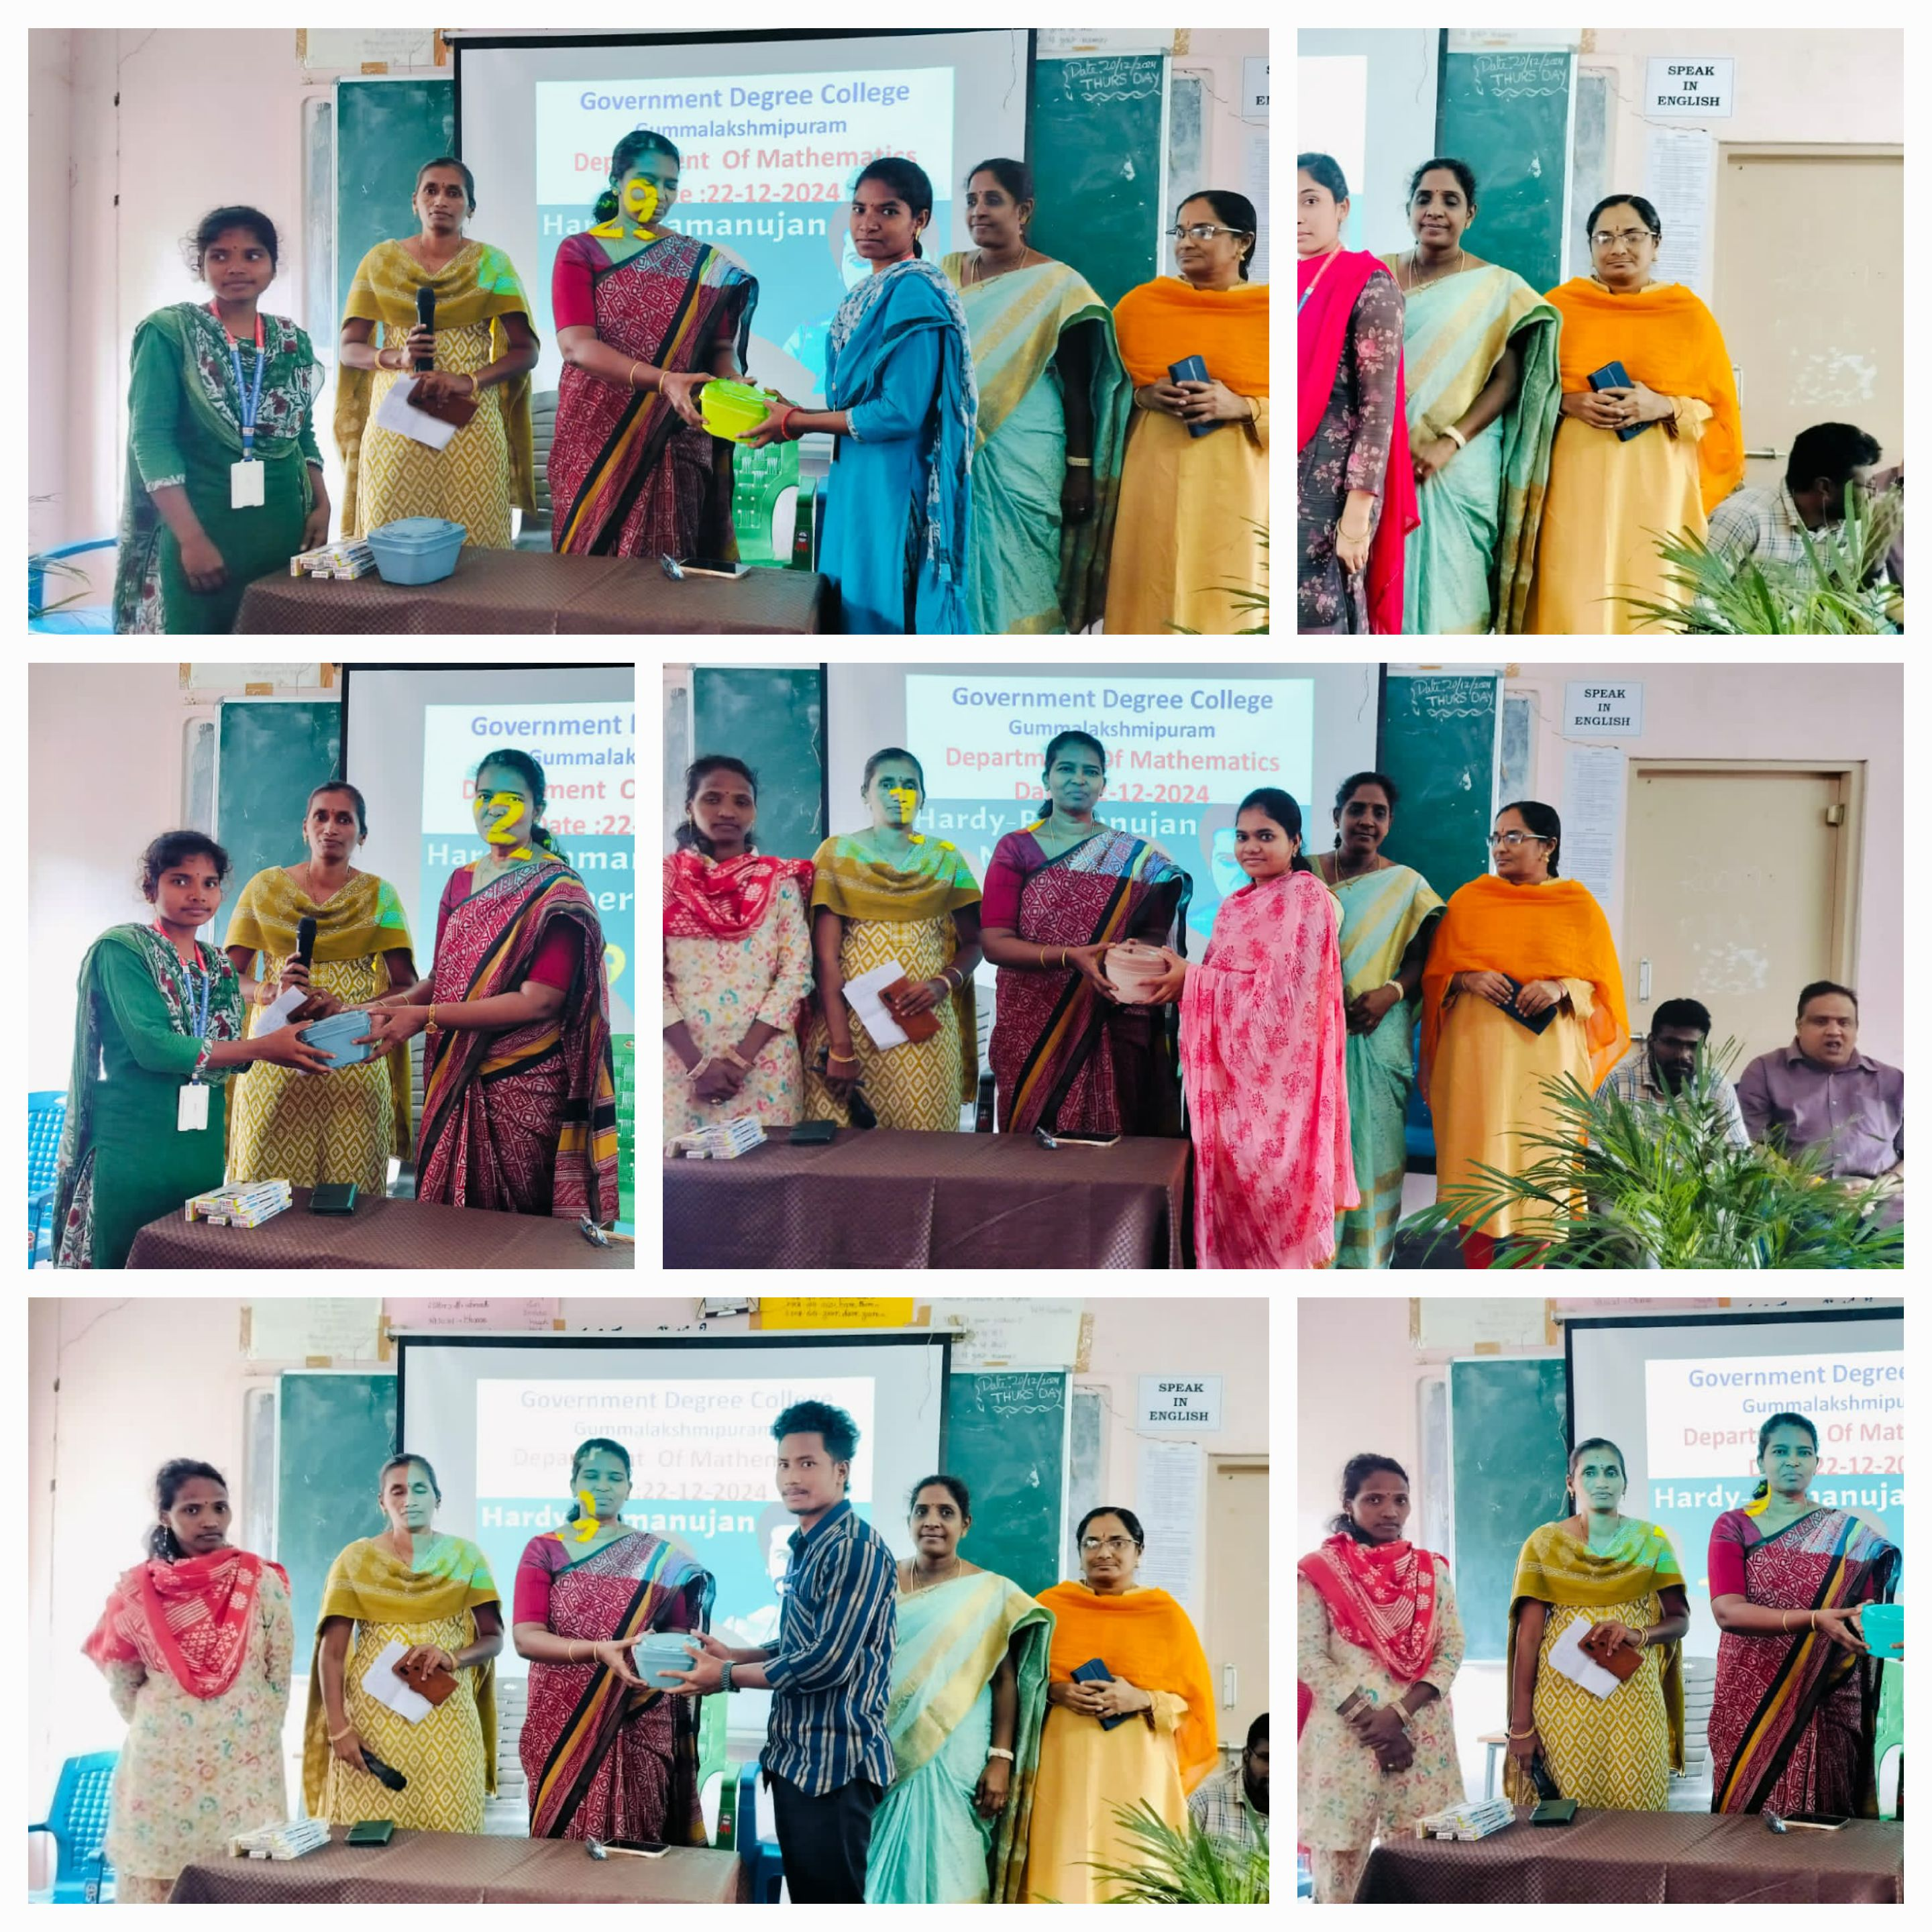

To encourage and recognize the students' efforts, **Dr. T. Sreevaram, Principal, distributed prizes to the participants** who contributed by preparing and presenting mathematics projects. Special prizes were awarded for the **best project** as well.

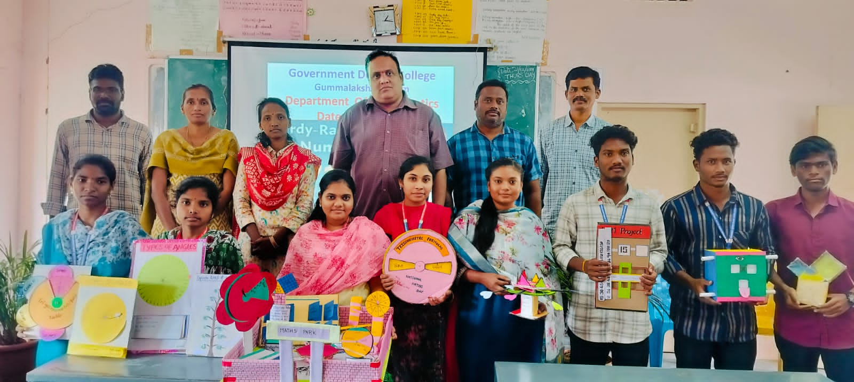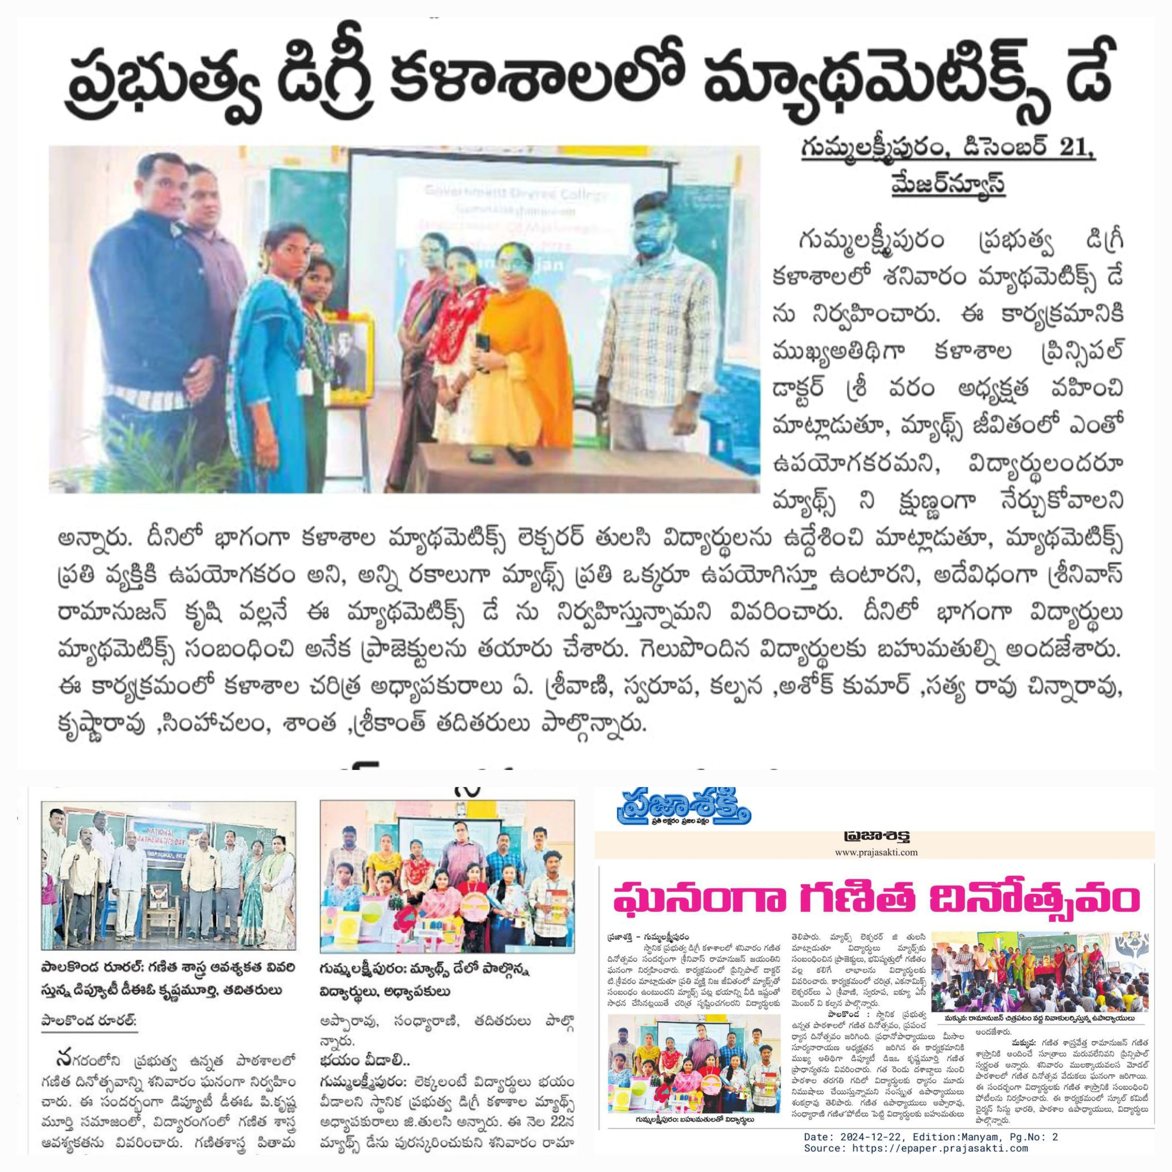

The event saw enthusiastic participation from **faculty members and students**, and it successfully fostered a positive learning environment and a greater appreciation for mathematics among students.

The program concluded with a vote of thanks, acknowledging the collective efforts of all faculty, students, and organizers in making the event a grand success.